eIDEAS

User Manual

Version 1.0

October 23rd, 2018

University of Regina

Health-Esteem

Quinn Bast

Wilson Nye

Shawn Clake

Tristan Heisler

Jennifer Herasymuik

Revision History

|  |  |  |  |
| --- | --- | --- | --- |
| Version Number | Change Summary | Date | Updated By |
| 0.1 | Initial draft of the user manual | 10/23/18 | Quinn Bast |
| 0.2 | Further progress on the creation of the manual | 12/04/18 | Quinn Bast |

Table of Contents

**About this guide** **4**

**Viewing the Home Page** **4**

The navigation bar 5

**User Accounts** **7**

Registering a new account 7

Logging in with an existing account 9

Recovering a lost password 11

Changing and viewing account information 14

Logging out 15

**Ideas** **16**

Viewing ideas 16

Viewing drafts 18

Finding ideas 20

Using the filter 20

Creating an idea 22

Rating an idea 24

Commenting on an idea 25

Tracking an idea 26

Progressing an idea’s status 27

**Leaderboards Page** **30**

**Statistics Page** **32**

**FAQ Page** **33**

**Contact Page** **34**

# About this guide

This guide is intended to describe how to use the eIDEAS application which has been created for eHealth by the University of Regina’s Health-Esteem team. This guide provides basic information for end-users of the application and covers the general topics of ‘Accounts’, ‘Ideas’, ‘Points’, and ‘Administration’.

# Viewing the Home Page

When first opening the website, the homepage will appear. On the homepage, the user is provided with a featured image carousel as well as text segments outlining success stories, and what’s new. In addition to this featured content, a navigation bar is provided which allows the user to access the FAQ, Contact, Register, and Login pages.

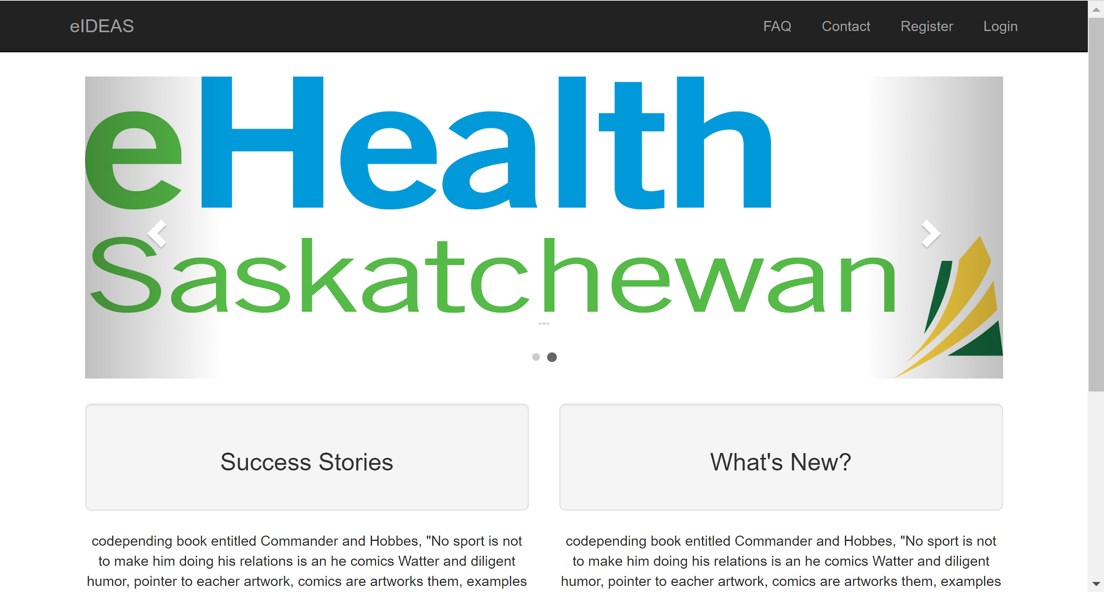

## The navigation bar

When first accessing the site, if the user is not logged in, the navigation bar will appear as in the following image:



Each button on the navigation bar is numbered and their explanation is given below.

|  |  |  |
| --- | --- | --- |
| 1 | eIDEAS | This button will take the user to the home page. |
| 2 | FAQ | This button will take the user to the FAQ page. This page provides a list of commonly asked questions and basic instructions about how the website works. |
| 3 | Contact | This button will take the user to the contact page. The contact page provides the user access to eHealth emails, phone numbers, and address for quick access. |
| 4 | Register | This button will take the user to the user registration page. This page will allow a user to create an account. |
| 5 | Login | This button will take the user ot the user login page. This page allows users with existing accounts to login to the website. |

If the user is logged into the website, the navigation bar will look slightly, providing more options so that the user can browse the application. The navigation bar for a logged in user can be seen below.



Each button on the navigation bar is numbered and their explanation is given below.

|  |  |  |
| --- | --- | --- |
| 1 | eIDEAS | This button will take the user to the home page. |
| 2 | Ideas | This button is a drop down which provides the user options about viewing and creating ideas. The dropdown has options for viewing all ideas, viewing your drafts, and creating a new idea. |
| 3 | Leaderboards | This button will take the user to the leaderboard page. |
| 4 | Statistics | This button will take the user to the statistics page. |
| 5 | FAQ | This button will take the user to the FAQ page. |
| 6 | Contact | This button will take the user to the contact page. |
| 7 | User Profile | This button will allow the user to change and view their account information. |
| 8 | Login | This button will take the user ot the user login page. This page allows users with existing accounts to login to the website. |

# 

# User Accounts

In order to access the website, a user must have registered for an account. Users are required to create an account in order to save the user’s ideas, drafts, comments, ratings, and more.

## Registering a new account

In order to register a new account, ensure that a user is not currently logged in. When a user is logged into the website the ‘Register’ tab does not appear within the navigation bar. In order to get to the account registration page, click the ‘Register’ button from the navigation menu as seen below.

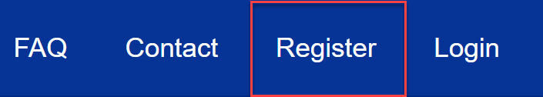

After clicking the Register button, the user is provided with the registration page as seen below.

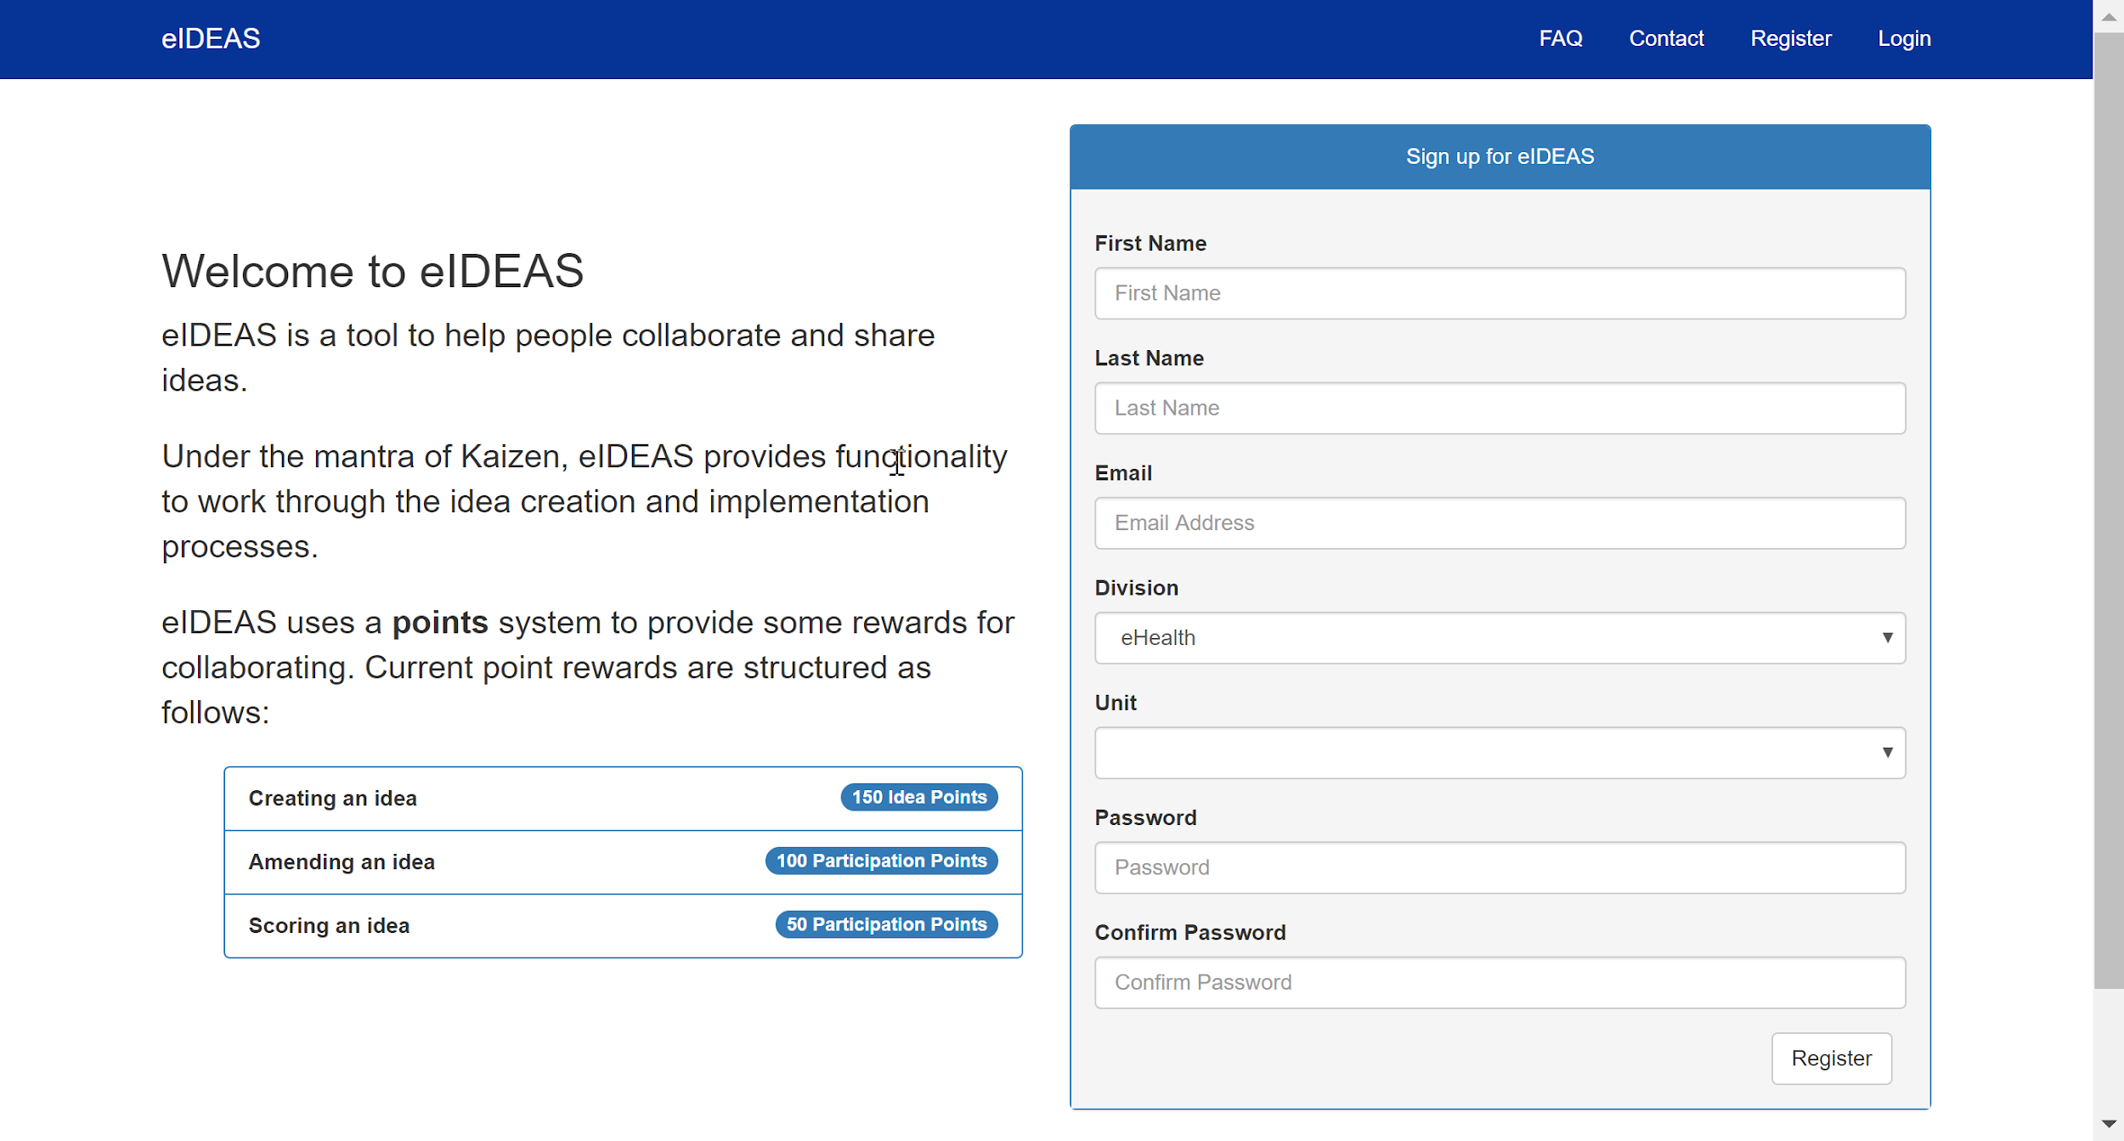

In order to create an account, the user needs to provide the following information:

|  |  |
| --- | --- |
| First Name | The user’s first name. |
| Last Name | The user’s last name. |
| Email | The user’s email. This will allow the user to recover their password and receive optional email notifications. |
| Division | The eHealth division that the user works within. |
| Unit | The unit within the division where the user works. |
| Password | The user’s password. This field must be between 6-100 characters, include a capital letter, lower case letter, number, and a symbol. |
| Confirm Password | Retype the user’s password. |

When registering for an account, if any of the input information is typed incorrectly, a popup box will appear to notify the user of any incorrect information. The account will not be created when there are errors with the input that the user has provided and the user will need to correct the errors before clicking register again. Once the user registers for an account, a confirmation email will be sent to the user’s email. The user will be able to login to their account, however without confirming their email they will not be able to reset their password.

## Logging in with an existing account

In order to login with an existing account, ensure that a user is not currently logged in. If a user is logged in, they must logout of their account before another user can be logged in. In order to get to the login page, click the ‘Login’ button from the navigation bar as shown below.

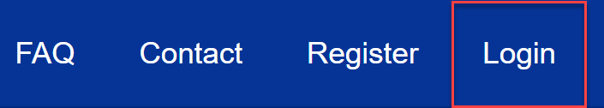

After clicking the login button, the user will be provided with the login screen as shown below.

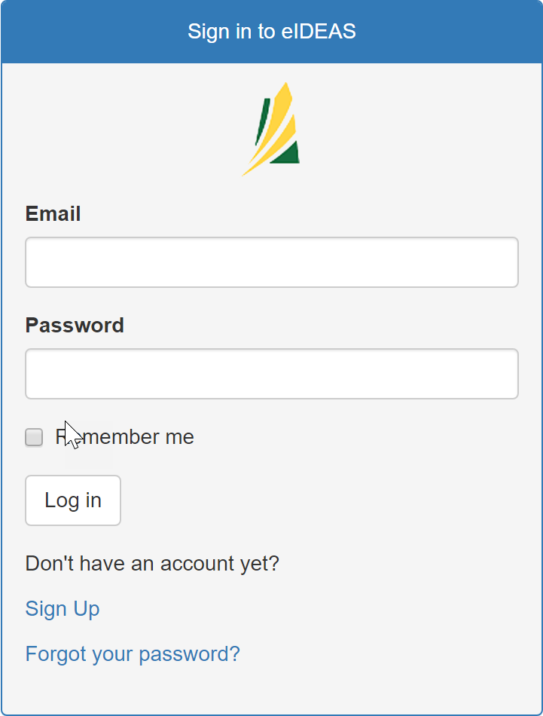

In order to login to their account, the user will need to enter their email address and password in order to eIDEAS. If the user is using a computer that is only used by themselves, clicking the “Remember Me” option will ensure that the user’s credentials are stored to the browser. Once the user has entered the appropriate credentials, clicking the “Log in” button will validate the user’s credentials and if the password is correct, it will sign the user in. If the user has forgotten their password the user will need to recover their password.

## Recovering a lost password

In order to recover a user’s password the user must have confirmed their email after they registered for an account. If the user did not confirm their email address, there is no way to reset the user’s password and they will need to register for a new account.

To recover a user’s password, first navigate to the login page by clicking the login tab in the navigation bar.



Once on the login page, underneath the login page, there is a link underneath the login page for “Forgot your password?”. Click this link to be taken to the password recovery page.

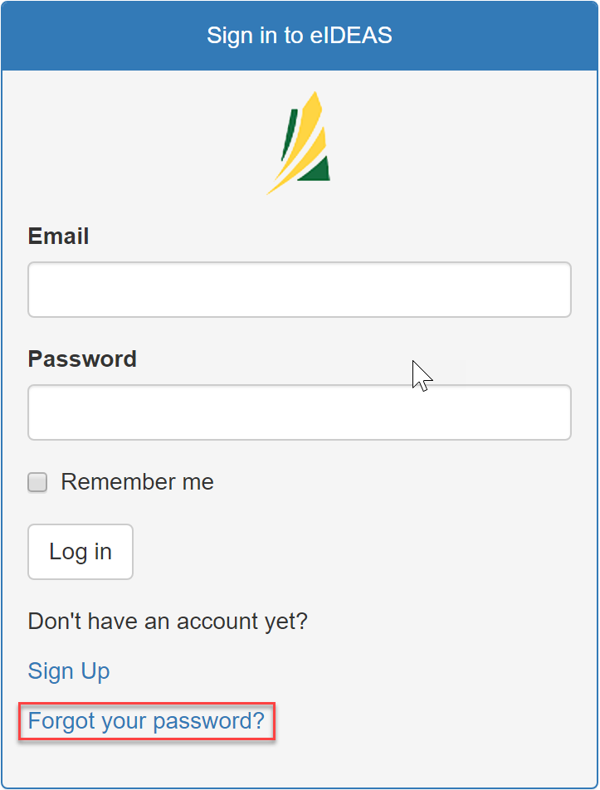

After clicking this link, the user will be taken to the password recovery page as shown below:

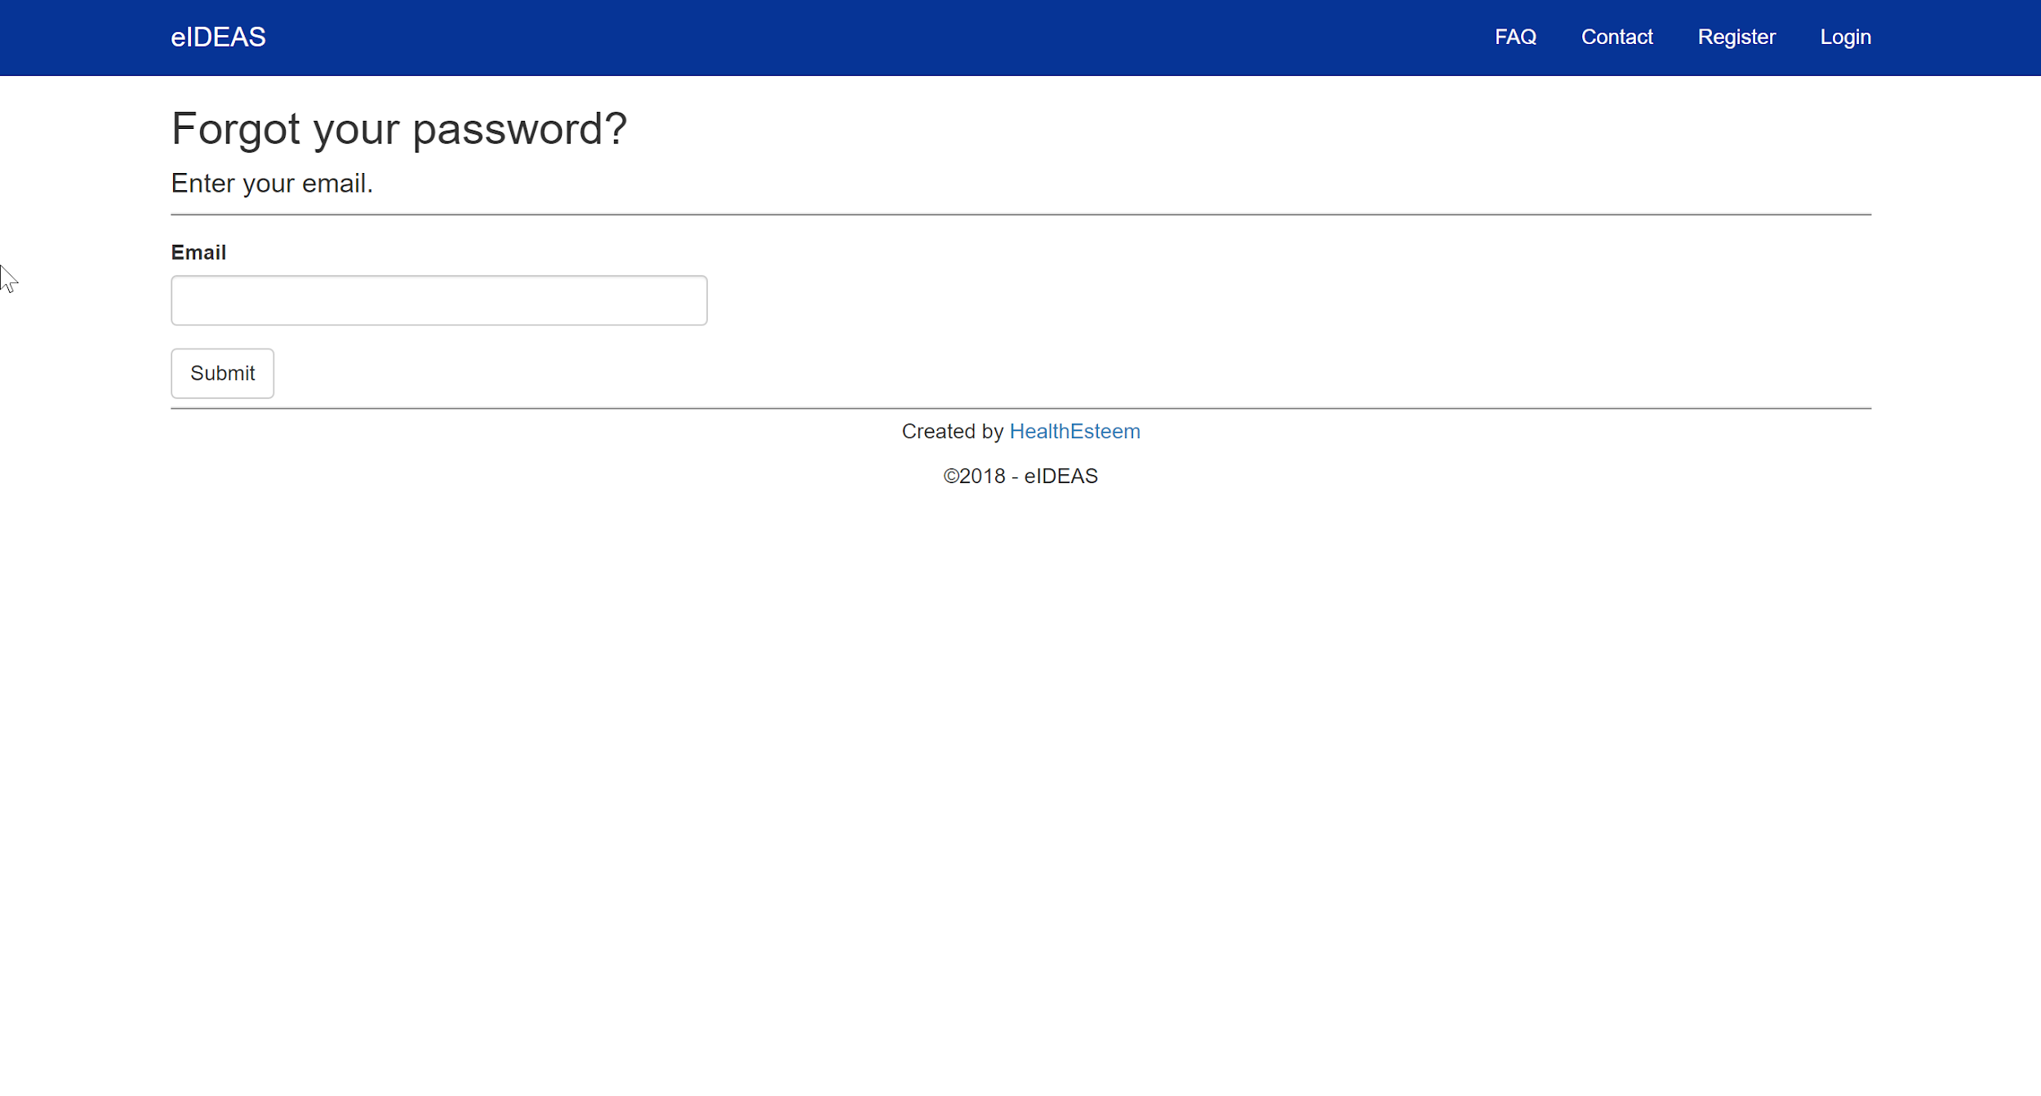

In order to recover a password, enter the email that was used when registering for an account. This is also the email address that is used to login to the system. After clicking submit, the user will be returned to the login page and a banner at the top of the page will appear stating “An email has been sent, check your email!”

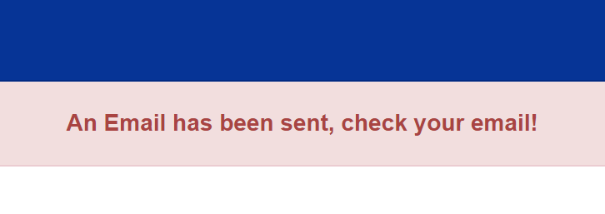

If this message does not appear, then

1. The user has not confirmed their email address. If this is the case, there is no option but to create a new account and ensure the user confirms their email address when registering.
2. The eIDEAS application cannot connect to the internet to send the email. Contact system admins to ensure that the application is connected to the internet.

If the banner appears, an email was able to be sent. In order to reset your password, check your email for a link to recover your password. The email will be sent from [healthesteem.noreply@gmail.com](mailto:healthesteem.noreply@gmail.com). The content of the email will appear like the screenshot below.

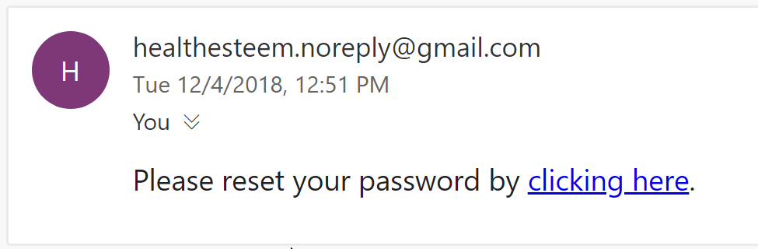

Clicking the link will take the user to the reset password page as seen below.

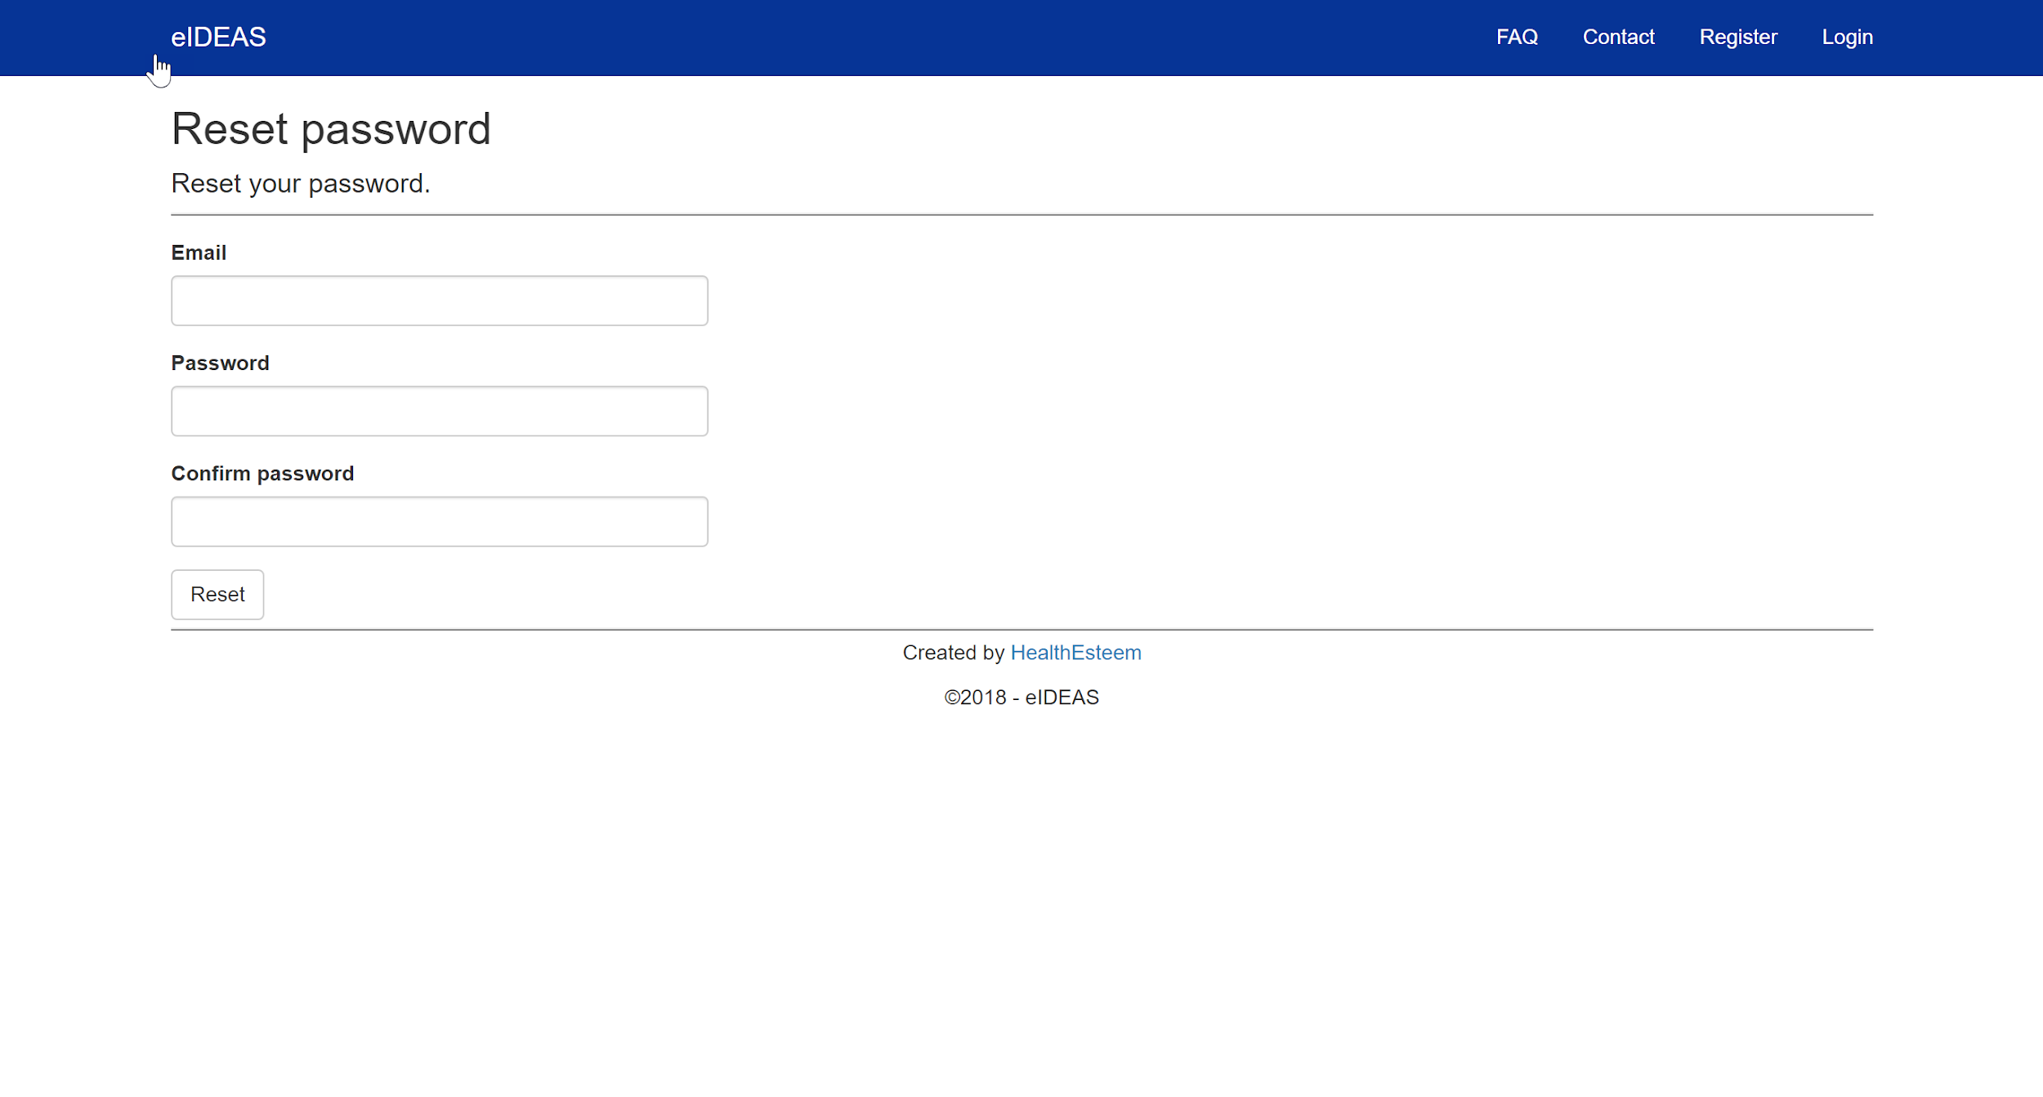

The user will need to re-type their email address, as well as provide the new password for their account. Once the user has entered the correct information and clicks ‘Reset’, the user will be informed that their password has been changed. The user may now login to their account using the newly updated password.

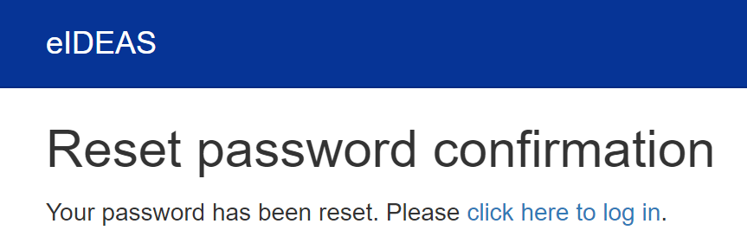

## Changing and viewing account information

In order to change and view the user’s account information, while logged in, click on your account in the top right of the navigation bar.



After clicking on your profile, the user is brought to the account management page. THere are two options on this page as seen below.

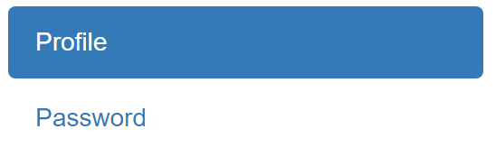

When viewing the “Profile” information, the user is provided with details about their account. The user is able to update their profile picture, change their email address, and phone number. The screenshot below shows the information that can be changed.

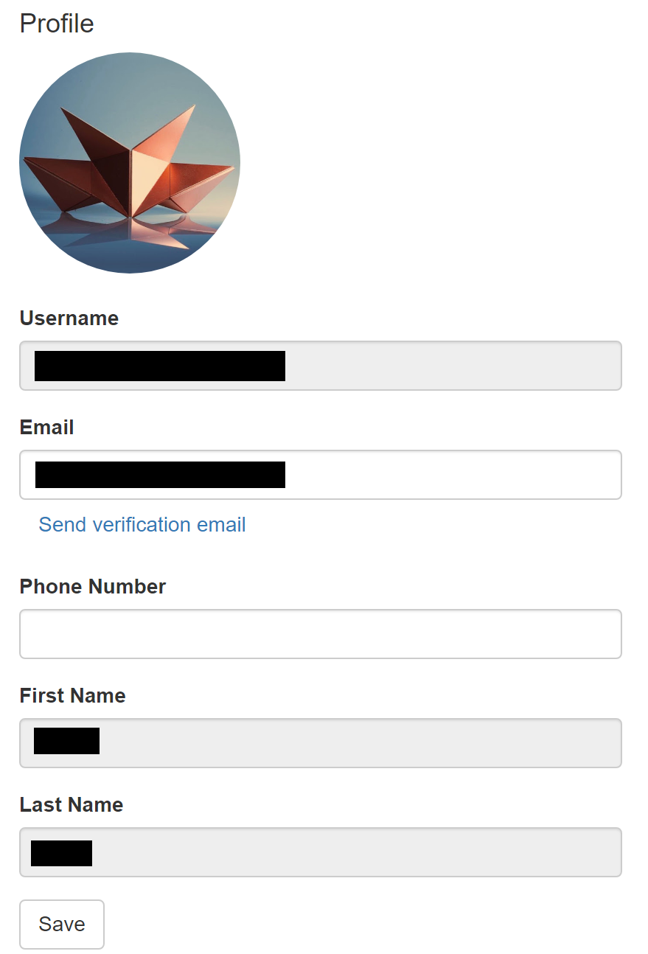

By clicking on the password tab, the user is given the ability to change their password as shown below.

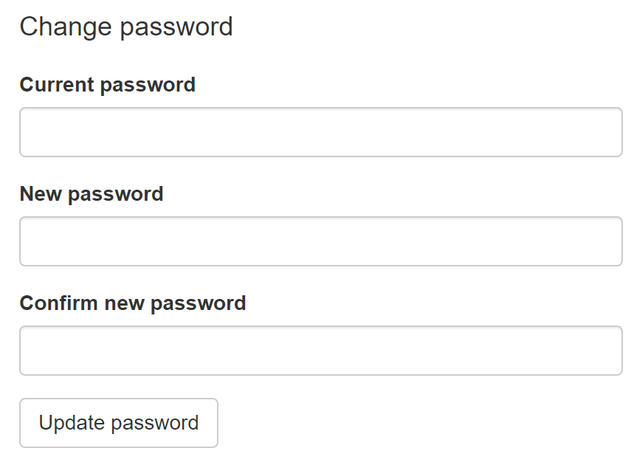

## Logging out

In order to logout of your account, click the logout button in the top right of the navigation bar.



# Ideas

The core of the application revolves around creating and sharing ideas with other users. Being able to create and interact with various ideas is explained within the following sections of the user manual.

## Viewing ideas

In order to view all of the ideas that have been created, from the navigation bar, click on the ideas dropdown. From the dropdown, select the “Ideas” option as shown in the screenshot below.

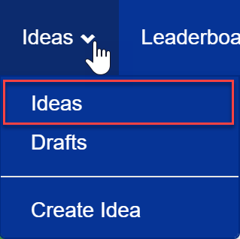

After clicking this button, the user will be taken to the idea dashboard where the user is able to see any idea that has been submitted by someone on their team. An overview of the dashboard can be seen below.

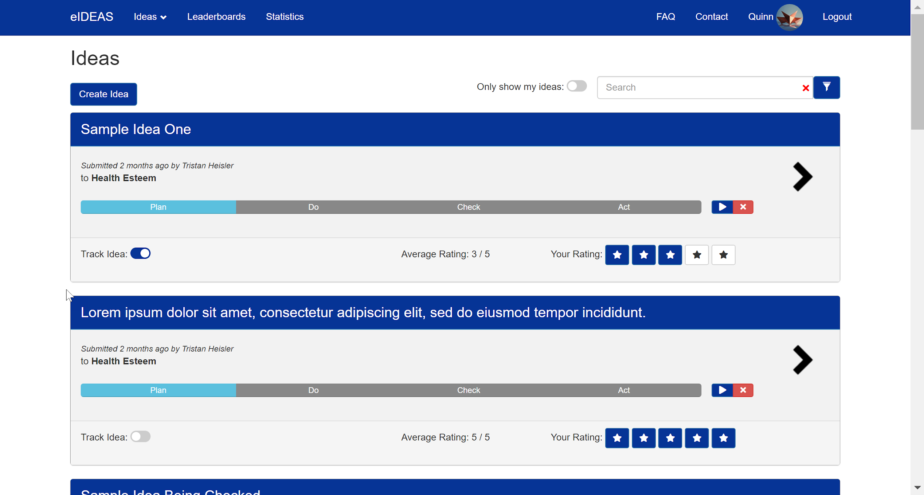

A single idea is shown below along with a description of the various options that can be clicked on the idea.

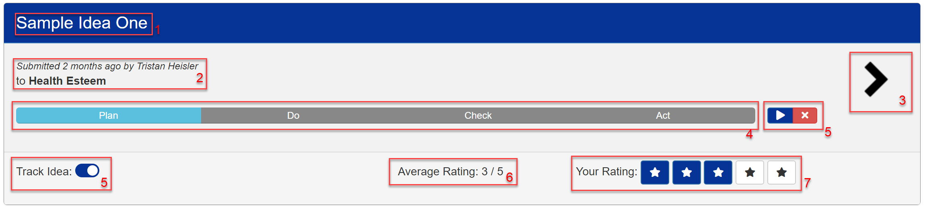

|  |  |  |
| --- | --- | --- |
| 1 | Idea title | The title of the idea |
| 2 | Date, Author, and Team | The date submitted, author of the idea, and their team. |
| 3 | Details button | Clicking this button or the idea’s title bar will expand the idea to show more details about the idea. Such as the problem description and the proposed solution. |
| 4 | Status bar | This bar shows the current status of the idea. |
| 5 | Progression tools | These tools allow the user to progress an idea through the different stages of the PDCA flow. |
| 6 | Average rating | This box shows the average rating of the idea based off of all user ratings of the idea. |
| 7 | Your rating | These boxes allow the user to rate an idea from 1-5 starts. |

In order to view additional information about the idea, clicking on the idea’s title bar or the details arrow will expand the idea to show the idea details as well as comments that have been provided by other users on the idea. A screenshot of the expanded view is shown below.

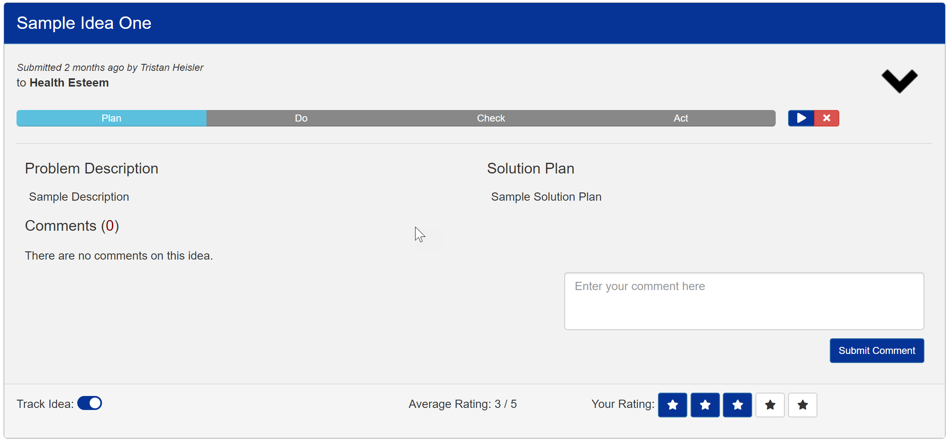

## Viewing drafts

In order to view your drafts, from the navigation bar, select ‘drafts’ from the Ideas dropdown menu as shown below.

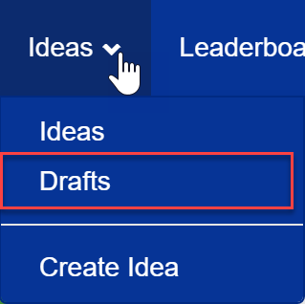

Once selected, the user will be taken to the drafts overview page which lists all of your drafts. A single draft is similar to a single idea on the ideas page but will have an “edit draft” button, allowing the user to update their draft.

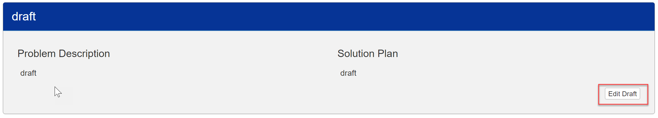

Once clicked, the user is able to update the idea as well as submit the idea if the draft is ready to be submitted as shown in the screenshot below.

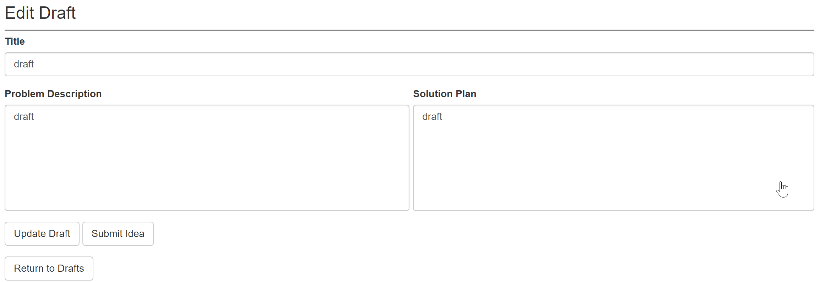

## Finding ideas

In order to search and filter ideas based on different criteria, various filtering options are avaliable for users to manage how they would like to view the ideas. While looking at the ideas page, the top of the page provides various tools for searching and filtering the ideas on the page. The various tools are shown in the screenshot below.



|  |  |  |
| --- | --- | --- |
| 1 | Perfonal filter | This toggle allows you to only show ideas that you have created. |
| 2 | Search box | This search box allows you to search for an idea title or author. |
| 3 | Filter | This filter allows you to fine-tune your search with advanced filtering. |

### Using the filter

Upon clicking the filter, you are provided with additional parameters to filter ideas on as shown in the screenshot below.

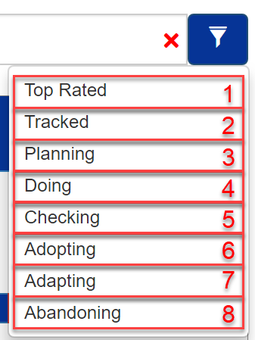

|  |  |  |
| --- | --- | --- |
| 1 | Top Rated | Sorts all of the ideas putting the most highly rated idea at the top. |
| 2 | Tracked | Shows only ideas that you are tracking. |
| 3 | Planning | Shows only ideas that are in the ‘Plan’ phase. |
| 4 | Doing | Shows only ideas that are in the ‘Do’ phase. |
| 5 | Checking | Shows only ideas that are in the ‘Check’ phase |
| 6 | Adopting | Shows only ideas that are in the ‘Adopt’ phase. |
| 7 | Adapting | Shows only ideas that are in the ‘Adapt’ phase |
| 8 | Abandoning | Shows only ideas that have been Abandoned. |

When using the filter, multiple different categories can be selected at a time and will stay applied until removed. For example, you can select “Planning” and “Doing” filters to select ideas that are either in the ‘Plan’ stage, or the ‘Do’ stage. When a filter has been applied, a checkmark will appear next to the filter, indicating that the filter is currently applied as shown below.

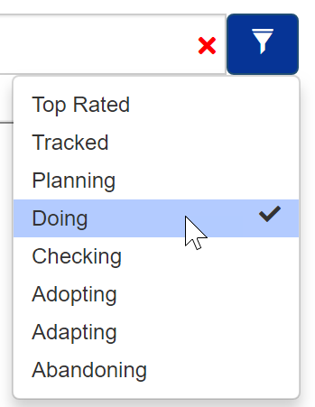

In order to remove a filter that is already applied, simply click the filter again and the checkmark will disappear, removing the filter from your view.

## Creating an idea

In order to create an idea, there are two methods that can be used.

**1. From the ideas overview:**

If the user is on the ideas page, at the top of the ideas page there is a button labeled “Create Idea” as shown in the screenshot below. Clicking this button will show a form to the user to create an idea.

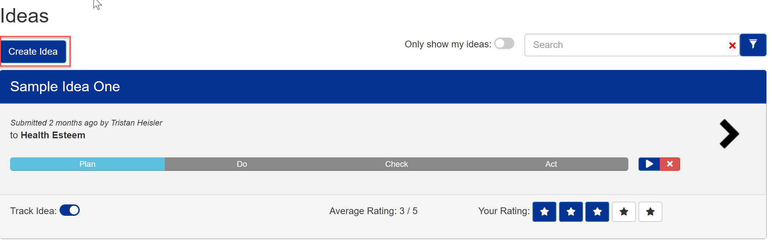

**2. From the navigation menu:**

If the user is not on the ideas page, the user is able to create an idea from anywhere in the application by using the navigation menu. In order to create an idea, from the navigation bar, select “Create Idea” located under the “Ideas” menu as shown below.

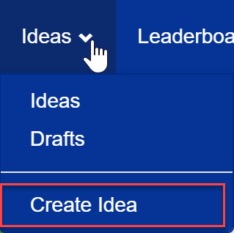

Clicking one of these two options will open the ‘Create Idea’ form for the user to create a new idea. The form will appear as seen below.

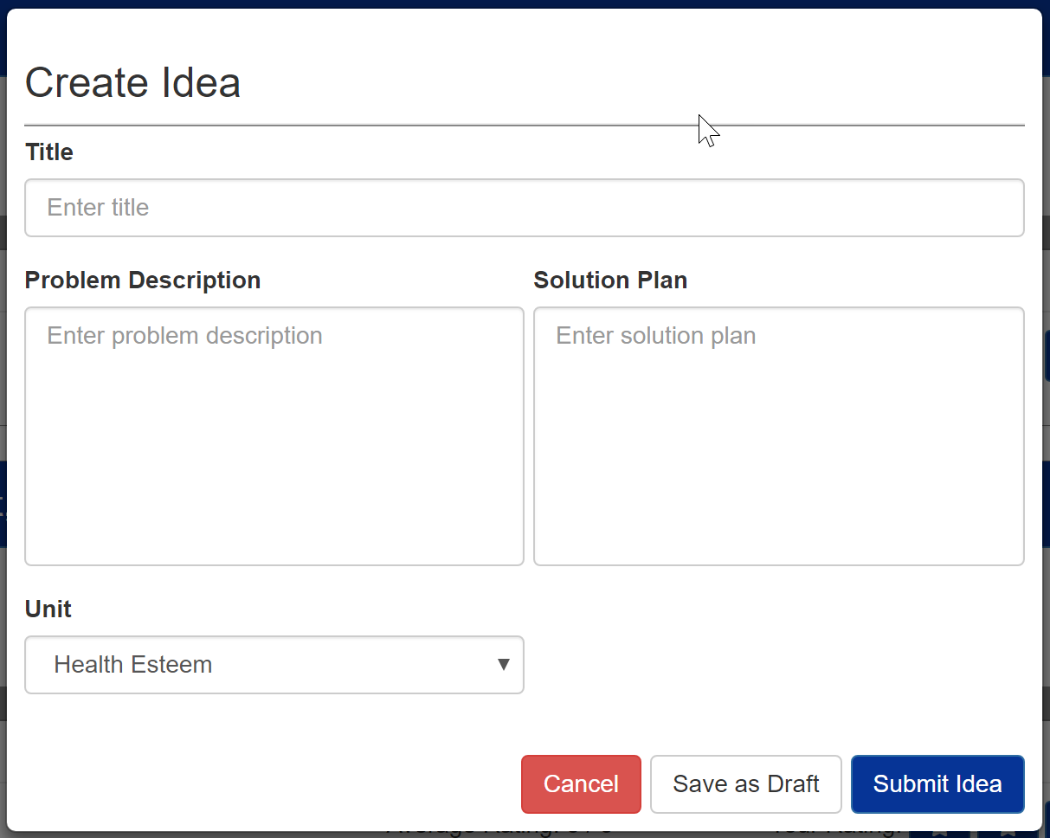

When creating a new idea, the user is required to provide a title for the idea, a problem description, and a solution plan. The title of the idea should be a brief overview indicating the general idea of the idea. The problem description allows users to provide additional details. This is where current conditions can be described and what difficulties are being faced. The solution plan is a proposed solution for the identified problem and how the idea can innovate upon the idea. The solution plan can also indicate the parties that would be involved in implementing the solution and any extra details.

Once the idea has been formulated, the user can choose to cancel their idea, save the idea as a draft in order to update their idea at a later date before submitting it, or submit the idea.

## Rating an idea

Users are able to rate ideas that they like or dislike on a 5 star system, 1 star being the lowest and 5 starts being the highest. In order to rate an idea, click on the stars that are shown below the idea as shown below.

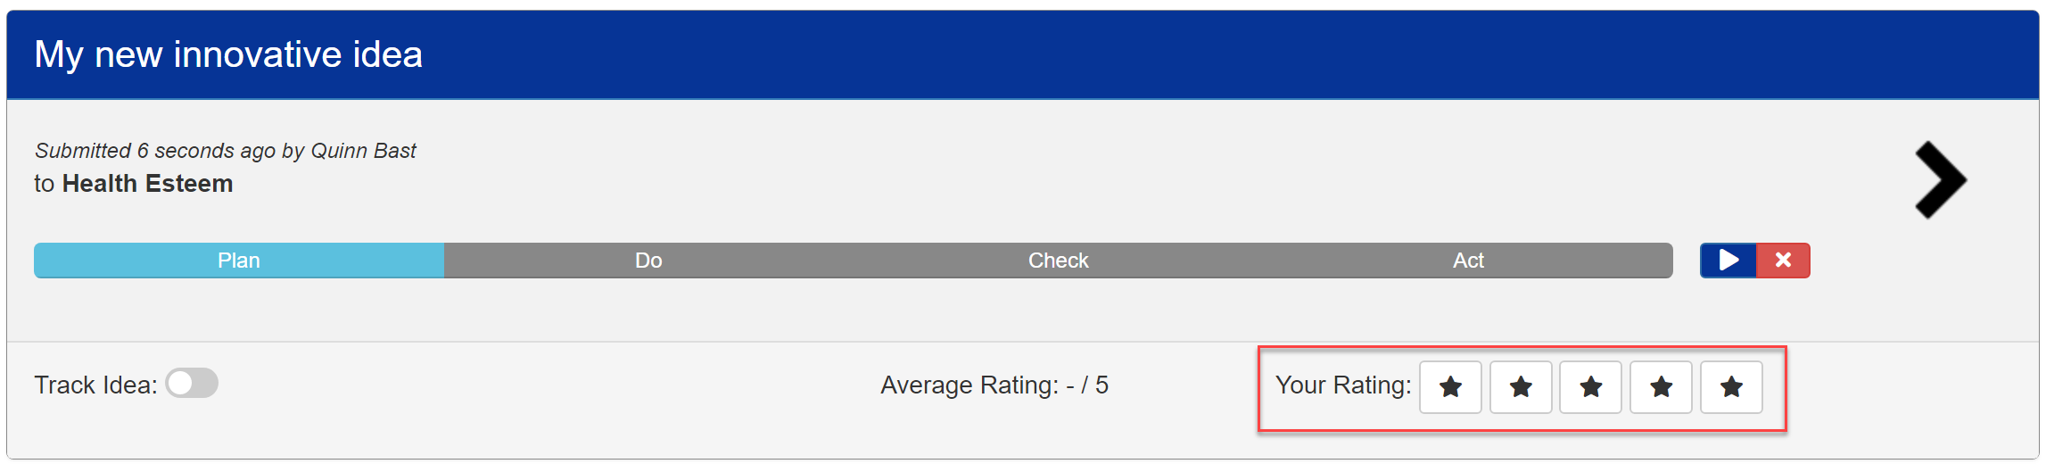

Once a user has rated an idea, their rate will be displayed by a corresponding number of blue stars lighting up. This indicates that the user has rated the idea and also shows the user that their rating has been recorded. After rating an idea, the rating will appear as seen below.

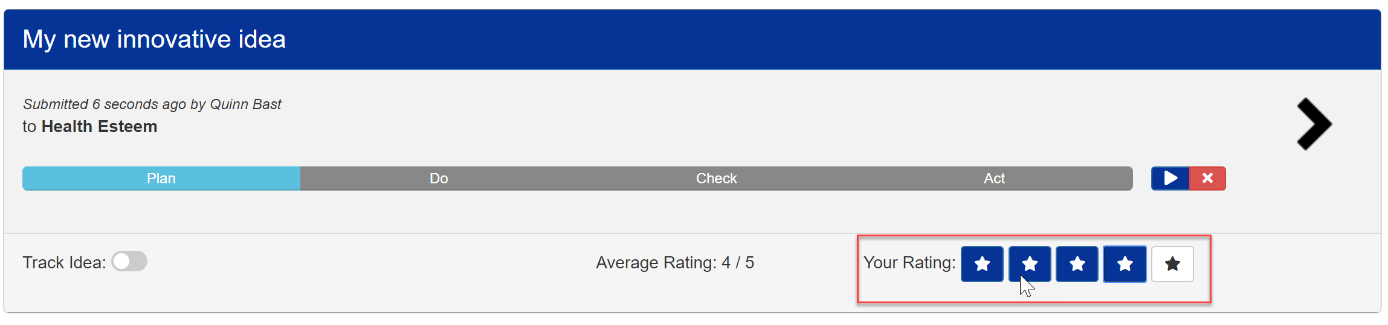

Ratings do not send emails to the idea creator.

## Commenting on an idea

In order to collaborate within teams, users are able to add comments to ideas. In order to add a comment to an idea, expand an idea to view the idea’s details. Once viewing the idea details, a form and submit button are available to submit comments on a given idea as shown in the picture below.

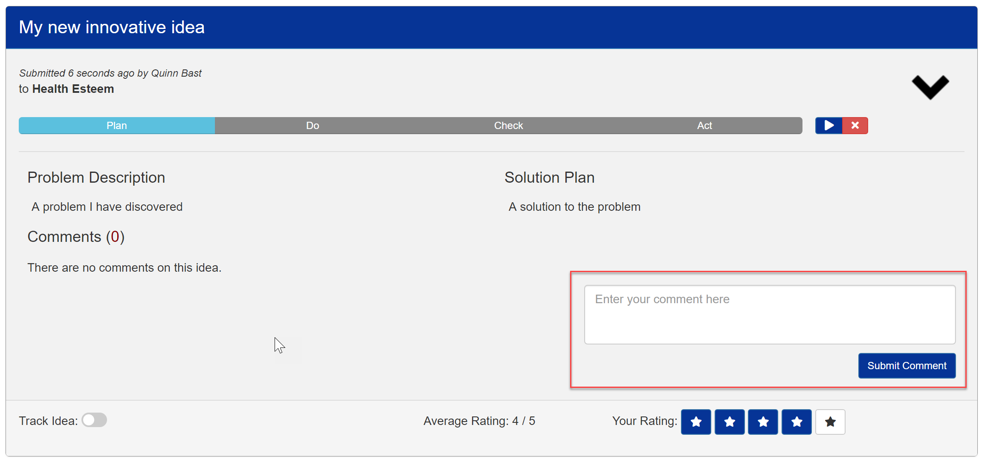

Using the indicated form, a user can type out a comment to an idea to leave additional details, inquire about their reasoning, add additional insights, or leave constructive criticism. Once a comment has been added, it will be added to the top of the comments list. The most recent comments are shown at the top of the post, allowing users to see updates without having to scroll to the bottom of the idea.

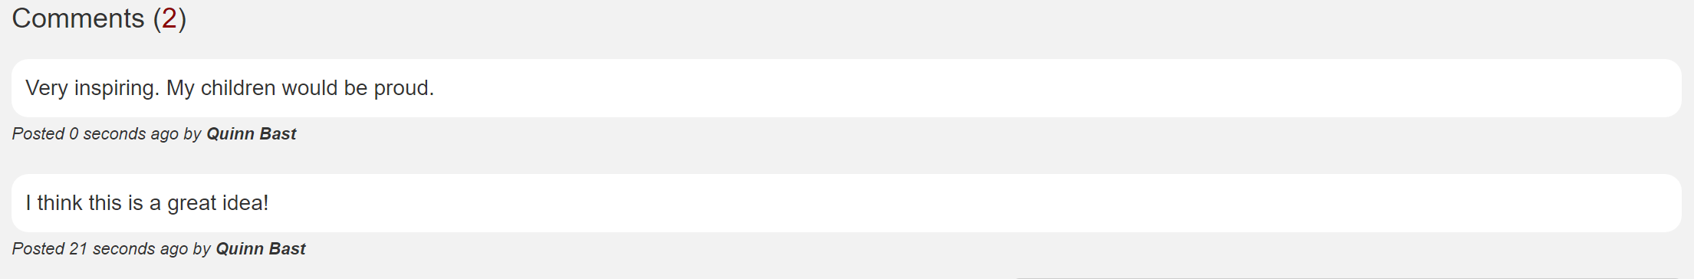

Comments do not send emails to the idea creator.

## Tracking an idea

Users have the ability to track an idea to allow filters to narrow down a search. By tracking an idea, a user can use the ‘Tracked’ filter which will only list ideas that the user is tracking, allowing a simplified view of the ideas that are most important to them. In order to track an idea, the user can use the toggle button that is visible within the idea overview as shown below.

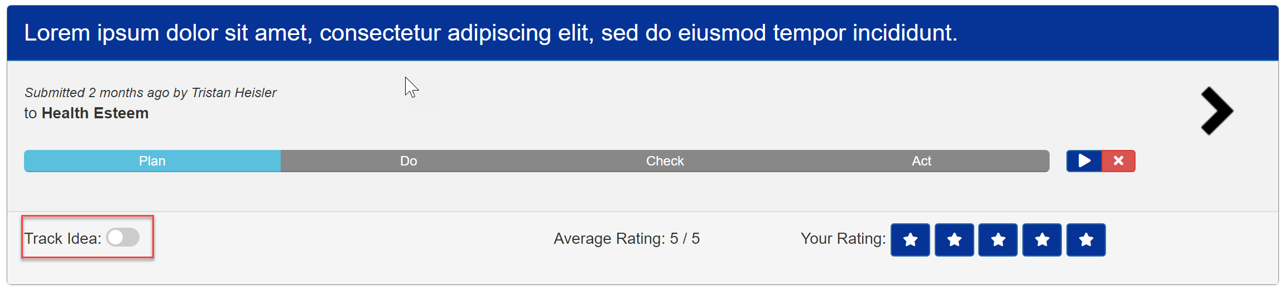

By enabling the toggle, a user can add the idea to their tracked ideas. This will ensure that the idea shows up when the user is filtering by ‘Tracked’. In order to untrack an idea, simply slide the toggle button back to be disabled.

Tracking ideas will not send email notifications to you.

## Progressing an idea’s status

As an idea is collaborated on, it will eventually flow through the PDCA (Plan-Do-Check-Act) cycle. When an idea is first created, it starts in the ‘Plan’ phase, as the idea is being planned and initialized. Once the idea has been thoroughly planned, the idea can start to be implemented and moved into the ‘Do’ phase. Once the solution has begun to take place, you can begin to ‘Check’ to see if the changes have made any significant impact, and based on the analysis, you may ‘Adopt’, ‘Adapt’, or ‘Abandon’ the idea. In order to progress an idea through the PDCA flow, two (or three depending on the idea’s status) buttons will appear to the right of the current PDCA status as shown below.

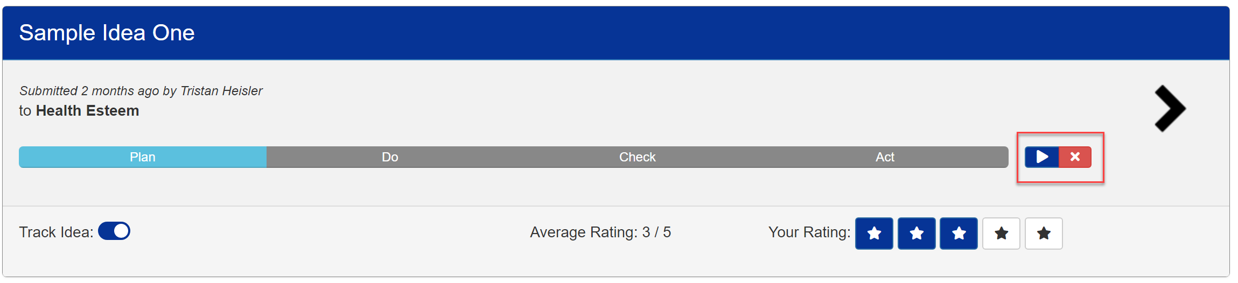

Hovering over each of the icos shows a tooltip of what each of the icons do. In the ‘Plan’ and ‘Do’ phases of an idea, the only options are to advance the idea to the next phase, or to abandon the idea. These options are indicated by the icons shown below.

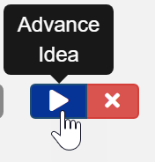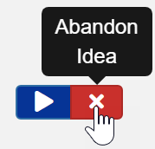

While in the ‘Check’ phase of an idea, an idea has three possibilities for a status change. The idea can be ‘Adopted’, ‘Adapted’, or ‘Abandoned’. Thus, three icons appear at this phase and are indicated below.

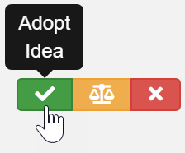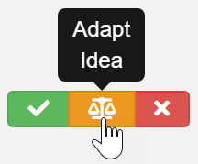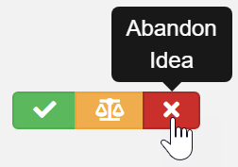

When clicking the ‘Advance Idea’ or ‘Adopt Idea’ options, the user is prompted with a modal asking them to confirm their change of status. Changing the status of an idea cannot be undone, and this modal is used to ensure that the user knows there is no going back after the status has been updated.

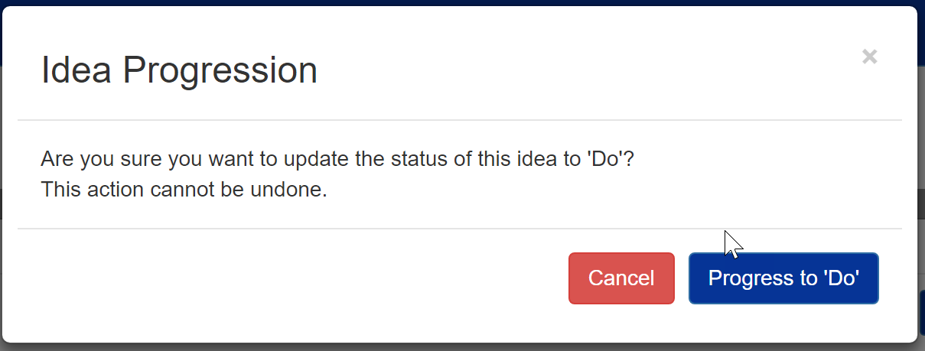

The user can confirm their actions by clicking the ‘Progress’ button, or they may cancel by clicking off of the modal or clicking the cancel button.

When a user clicks the ‘Adapt’ or ‘Abandon’ buttons, the user is prompted for a ‘Reason for Adaptation’ or ‘Reason for Abandonment’ as seen in the screenshot below.

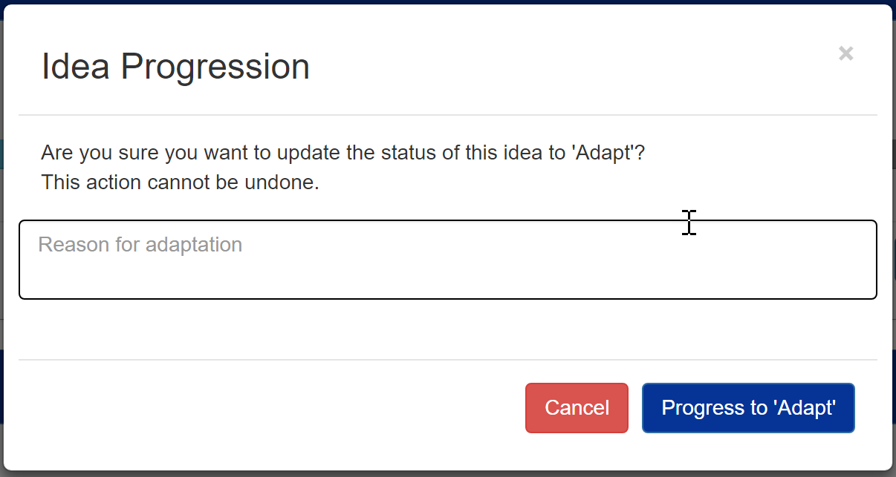

This is a required field and the user must provide some kind of explanation as to why the idea is being abandoned or adapted. Once an idea’s status has been updated, the idea’s status will be reflected in the idea status bar by proceeding to the next or final status after the progression has been confirmed by the user.









# Leaderboards Page

The leaderboards page allows users to compare their activity within the application to other user’s and team activity. Points are given to users for a variety of actions. 150 Idea points are given for the created of every idea, 100 Participation points are given to every comment on an idea, and 50 Participation points are given when you rate another user’s idea.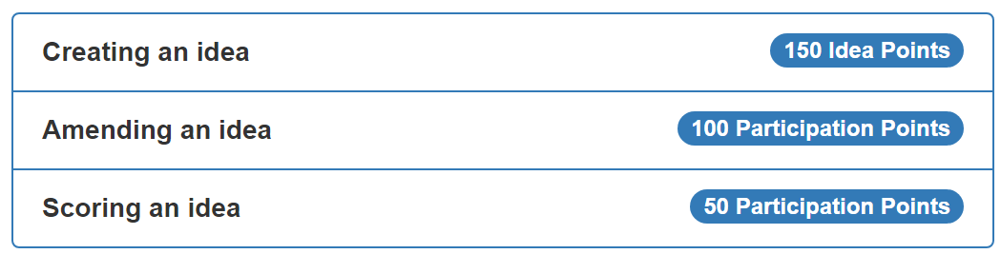

In order to view the leaderboard, click the ‘Leaderboards’ in the navigation bar as shown below.



The leaderboard page will show the individual leaderboard by default, listing every user and the number of points that they have accumulated. Users with the most points appear at the top while users with a lower number of points appear near the bottom. Get to the top by creating ideas, commenting, and rating ideas!

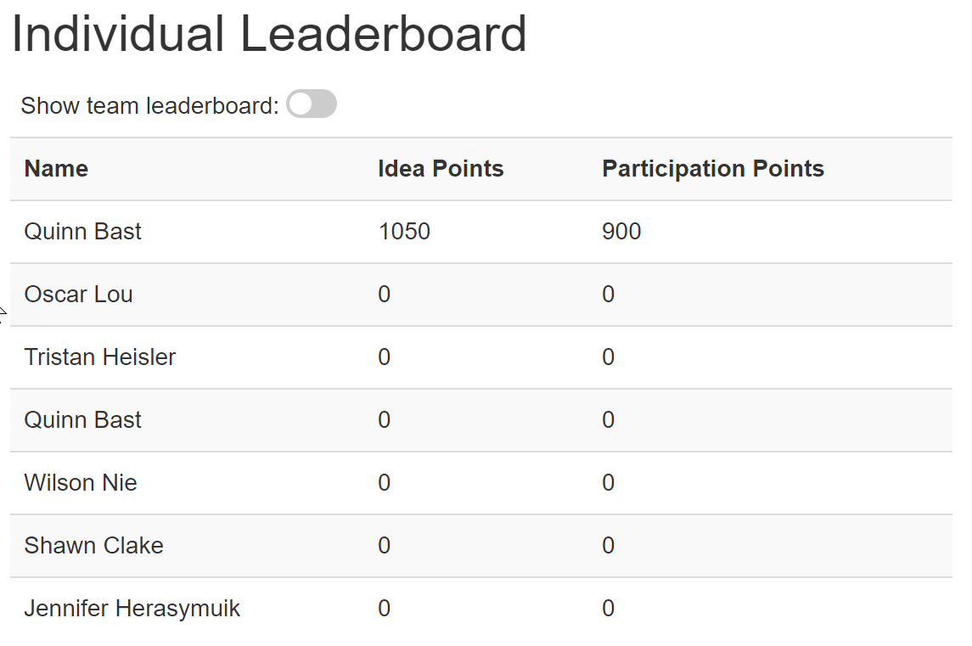

View the team leaderboard by using the toggle at the top of the page. This allows switching between the individual and team leaderboards.

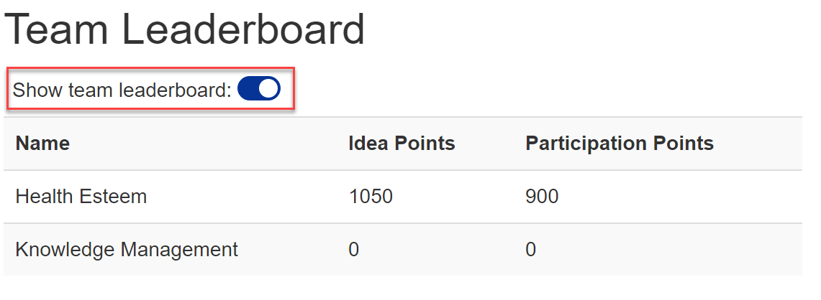

The team leaderboard will show the collective total of each team’s points. Teams with the most points will appear at the top while teams with the least amount of points will appear at the bottom.

# Statistics Page

Statistics are able to be viewed within the application for a variety of different metrics. These statistics include things like the total number of ideas submitted, average participation points per month, average idea rating, and more. View the statistics page by clicking ‘Statistics’ in the navigation bar as shown below.



Once clicked, the statistics page will appear, allowing the user to view their individual statistics, their team’s statistics, and global statistics for every user. When first visiting the page, the global statistics are displayed by default. In order to change what type of statistics are displayed, click the dropdown box as seen below.

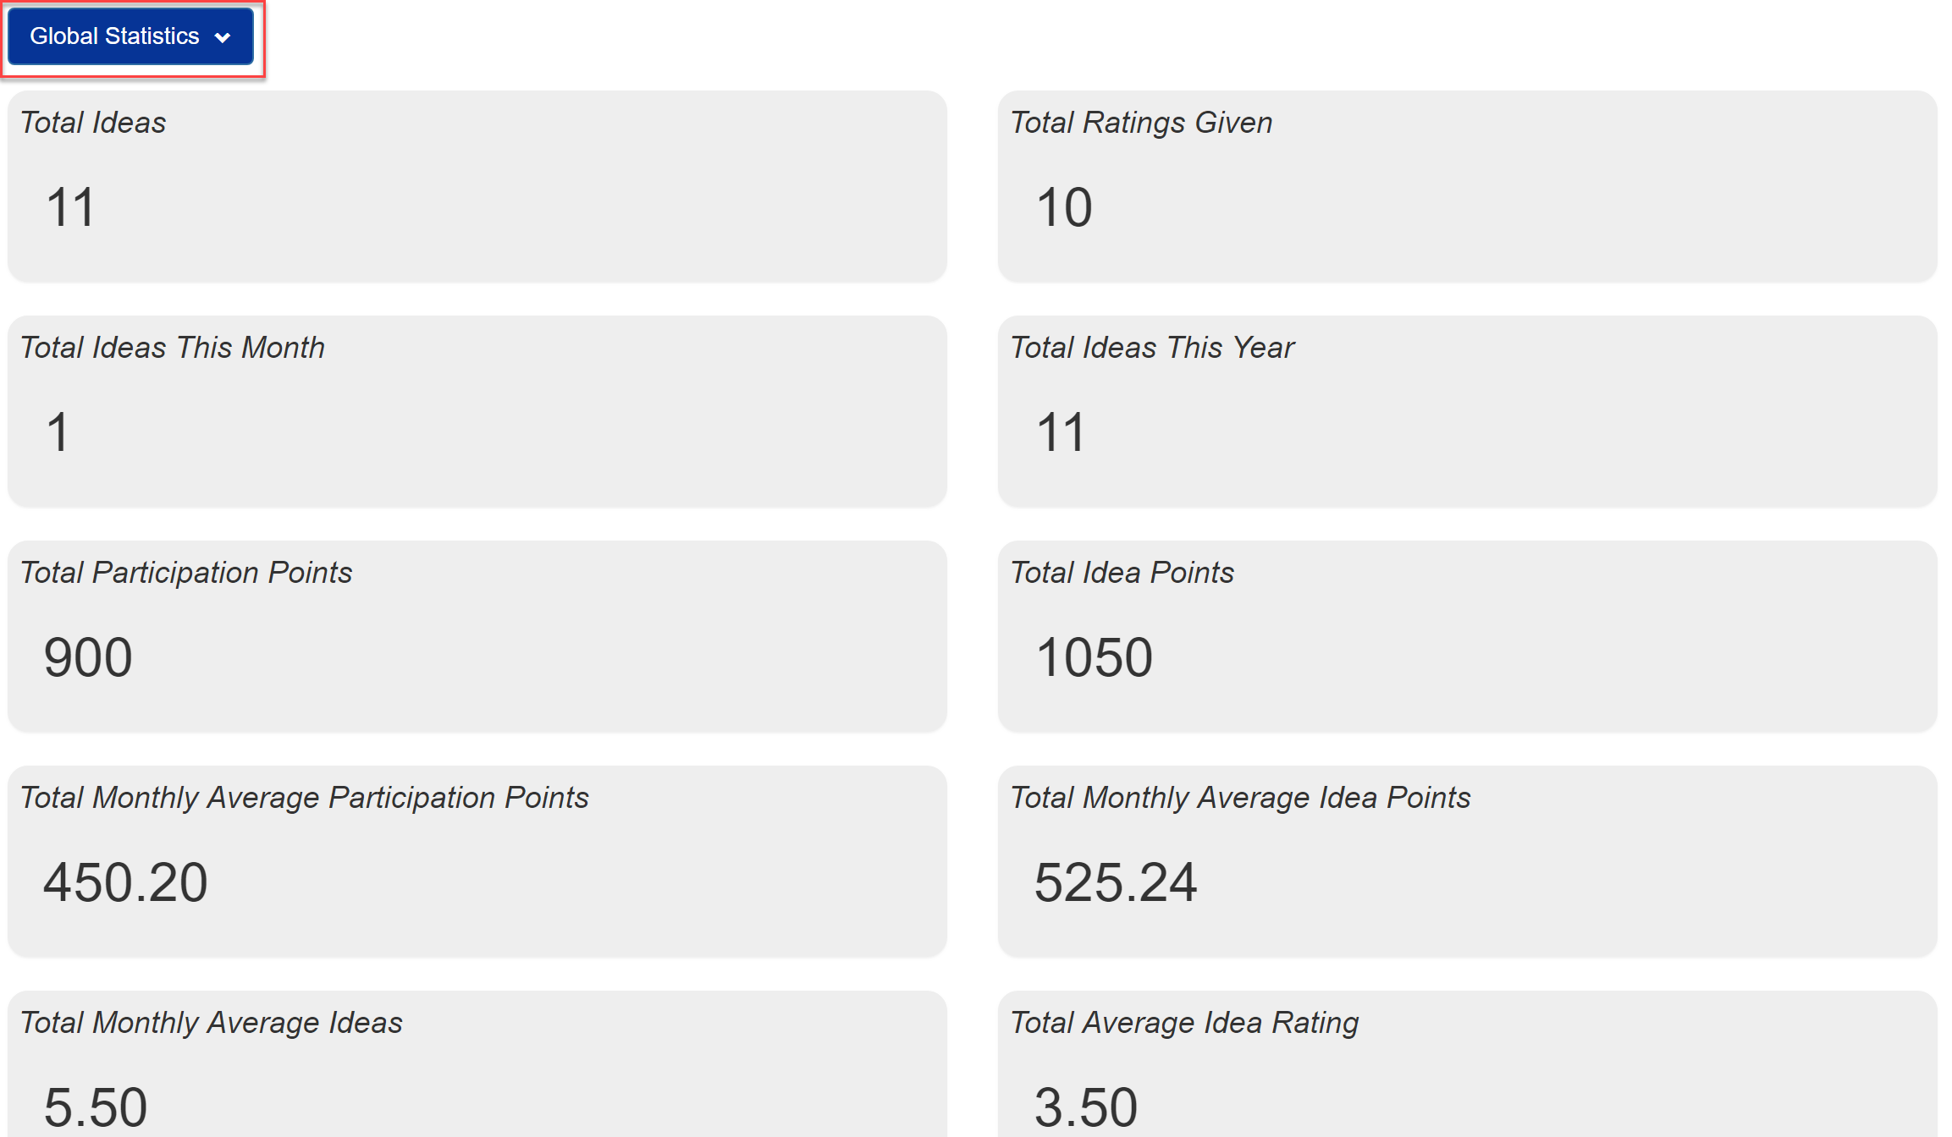

After clicking on the dropdown, the user can select what type of statistics they would like to view.

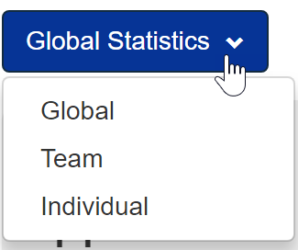

# FAQ Page

To view commonly asked questions, the user can view the FAQ page. This FAQ will provide a list of commonly asked questions as well as potential solutions to these questions. To access the FAQ page, click on the FAQ in the navigation bar as indicated above.



The FAQ page provides a list of some common questions that may are asked about the application and how to solve them. This page is only an overview of some functionalities and this user manual provides a more in-depth explanation of the application.

# Contact Page

If you need to contact someone about problems with your account, or bugs within the application, the contact us page provides details about who to contact. In order to access the contact us page, click the ‘Contact’ button in the navigation bar.



Once selected, the contact page will show a list of contact information about the eHEALTH organization as seen below.

